In C++, inheritance is supported by allowing one class to incorporate another class into its declaration. Inheritance allows a hierarchy of classes to be built, moving from most general to most specific.

The process involves first defining a base class, which defines those qualities common to all objects to be derived from the base. The base class represents the most general description. The classes derived from the base are usually referred to as derived classes.

A derived class includes all features of the generic base class and then adds qualities specific to the derived class.

the building class is declared, as shown here. It will serve as the base for two derived classes

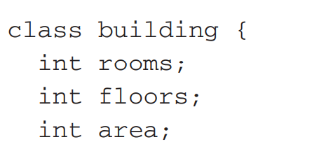

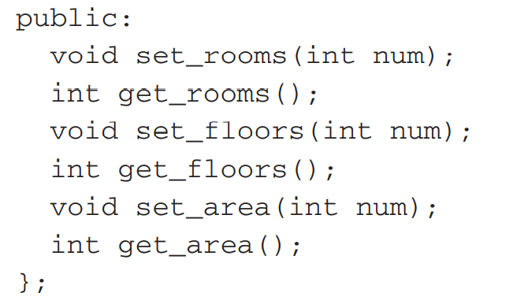

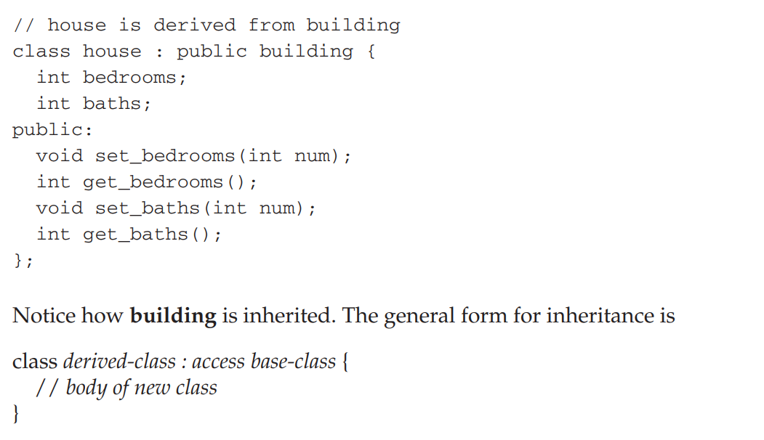

A derived class has direct access to both its own members and the public members of the base class

Here is a program illustrating inheritance. It creates two derived classes of building using inheritance; one is house, the other, school

#include <iostream>

using namespace std;

class building { //main class//

int rooms; //private//

int floors;

int area;

public:

void set_rooms(int num);

int get_rooms();

void set_floors(int num);

int get_floors();

void set_area(int num);

int get_area();

};

// house is derived from main building class//

class house : public building {

int bedrooms;

int baths;

public:

void set_bedrooms(int num);

int get_bedrooms();

void set_baths(int num);

int get_baths();

};

// school is also derived from main class or base class building//

class school : public building {

int classrooms;

int offices;

public:

void set_classrooms(int num);

int get_classrooms();

void set_offices(int num);

int get_offices();

};

void building::set_rooms(int num) //this for base class//

{

rooms = num;

}

void building::set_floors(int num)

{

floors = num;

}

void building::set_area(int num)

{

area = num;

}

int building::get_rooms()

{

return rooms;

}

int building::get_floors()

{

return floors;

}

int building::get_area()

{

return area;

}

void house::set_bedrooms(int num) //this is for derived class house//

{

bedrooms = num;

}

void house::set_baths(int num)

{

baths = num;

}

int house::get_bedrooms()

{

return bedrooms;

}

int house::get_baths()

{

return baths;

}

void school::set_classrooms(int num) //this is for derived class school//

{

classrooms = num;

}

void school::set_offices(int num)

{

offices = num;

}

int school::get_classrooms()

{

return classrooms;

}

int school::get_offices()

{

return offices;

}

int main()

{

house h; //object h for house class//

school s; //object s for school class//

h.set_rooms(12);

h.set_floors(3);

h.set_area(4500);

h.set_bedrooms(5);h.set_baths(3);

cout << "house has " << h.get_bedrooms();

cout << " bedrooms\n";

s.set_rooms(200);

s.set_classrooms(180);

s.set_offices(5);

s.set_area(25000);

cout << "school has " << s.get_classrooms();

cout << " classrooms\n";

cout << "Its area is " << s.get_area();

return 0;

}